[cover sheet]

2

ASSIGNMENT 2

**DEFECT ANALYSIS REPORT**

CSE 6329 -- SOFTWARE MEASUREMENT AND QUALITY ENGINEERING

Professor Dennis J. Frailey

**Fall, 2015**

NAME ___Tasmeen Kaur Kathuria___

|  |  |  |  |  |  |  |  |  |  |  |  |
| --- | --- | --- | --- | --- | --- | --- | --- | --- | --- | --- | --- |
| Grading template Student do not write inside this box | | | | | | | | | | | |
| _______  (/16) | 1.0 Description of Analysis Tool (spreadsheet) | | | | | | | | (16 points) | | |
|  | 2.0 Details for each of the Six Measures/Graphs | | | | | | | | | | |
|  | (1 pt)  Overview  (2.n.1) | | (3 pts)  Sample Graph(s)  (2.n.2) | | | (4 pts)  Generic  Description  (2.n.3) | | (4 pts)  Analysis Discussion  (2.n.4) | | (2 pts)  How to Generate  (2.n.6) | |
| ________  n=1 (/14) | __________ | | __________ | | | __________ | | __________ | | __________ | |
| ________  n=2 (/14) | __________ | | __________ | | | __________ | | __________ | | __________ | |
| ________  n=3 (/14) | __________ | | __________ | | | __________ | | __________ | | __________ | |
| ________  n=4 (/14) | __________ | | __________ | | | __________ | | __________ | | __________ | |
| ________  n=5 (/14) | __________ | | __________ | | | __________ | | __________ | | __________ | |
| ________  n=6 (/14) | __________ | | __________ | | | __________ | | __________ | | __________ | |
| _______  (/100) | Total Assignment Grade | | | | | | | | | | |
|  |  |  | |  |  | |  | | | |  |

**Defect Analysis Report**

1. **Introduction**
   1. **Purpose of This Report**

This report shows the results of analyzing three years of defect data on our released products. The purpose is to gain a greater understanding of the quality levels of our released products and to determine whether changes in our quality engineering procedures have resulted in changes in product quality.

* 1. **Structure of Analysis Tool**

In order to analyze defect data, we have created a workbook in Microsoft Excel™. The data is collected monthly and the work book contains 4 worksheets. The first worksheet contains data collected monthly, second worksheet contains post quality history, and third sheet has standard deviation, fourth has current quality, current quality by number, and current quality by history and fifth has post quality analysis. The data collection worksheet is labeled as a4data (the new corrected data is being used). The spreadsheet has 2 rows for each release of each product. First row ‘N’ is new defects detected and second row ‘C’ has number of defects corrected. So each month new column is added and number of new defects and corrected defects are recorded for current active products.

The data collection worksheet looks like this ( below):

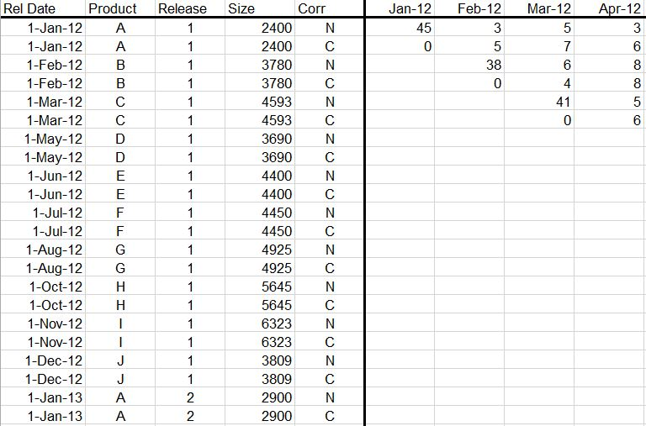

* 1. **Analyses and Graphs**

We have analyzed the data in six different ways, resulting in six different graphs:

* Post Release Quality,
* Post Release Quality History,
* Current Total Quality,
* Current Total Quality Normalized by Product Size,
* Current Total Quality Normalized by Number of Active Product Releases, and
* Standard Deviation of defects

The data necessary to perform these measurements have been collected monthly for each active software product, over the past three years. The data are stored in the **data spreadsheet**, named A02datanew.xlsx. It has 4 spreadsheets namely a4data, Post quality History, Standard Deviation, current quality and post quality analysis.

1. A4data: This spreadsheet contains the data that is being used for analysis. Data is collected monthly and recorded for active products at a particular time. The spreadsheet has 2 rows for each release of each product. First row ‘N’ is new defects detected and second row ‘C’ has number of defects corrected. So each month new column is added and number of new defects and corrected defects are recorded for current active products.

The data collection worksheet looks like this (below):



1. Post Quality Analysis: This worksheet includes data for Product A including all its releases. From the given data total defects and total uncorrected defects are calculated. The worksheet has 3 graphs- One for single release and 2 for all the releases. The worksheet looks like this:

Post quality analysis for one release:

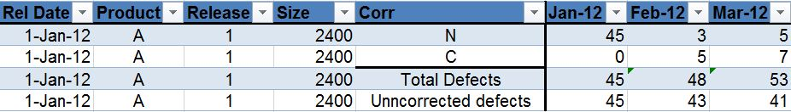

Post release quality for 3 separate releases:

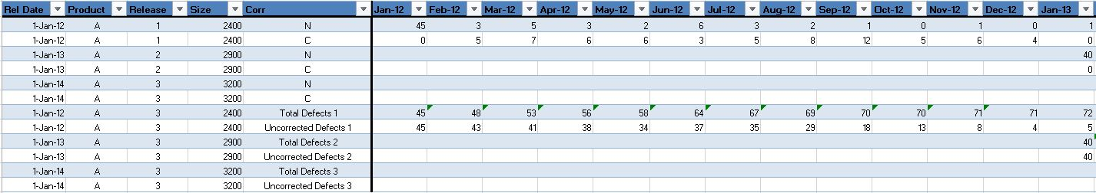

Post release quality for 3 combined releases:

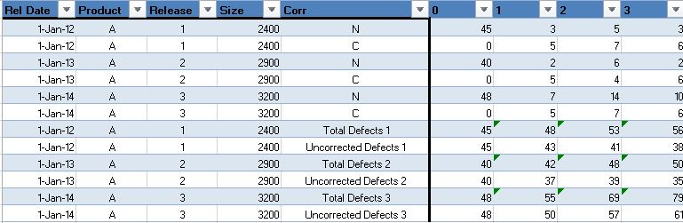

1. Post Quality History: This worksheet has data for only new defects being detected. New defects are recorded monthly, quarterly and yearly. From new defects being recorded best case, average case and worst cases are analyzed. The worksheet looks like this:

For monthly:



For Quarterly:



For Yearly:

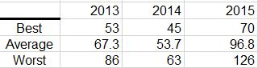

1. Current Quality: This worksheet contains data for all the products for 3 years. The worksheet looks like this:

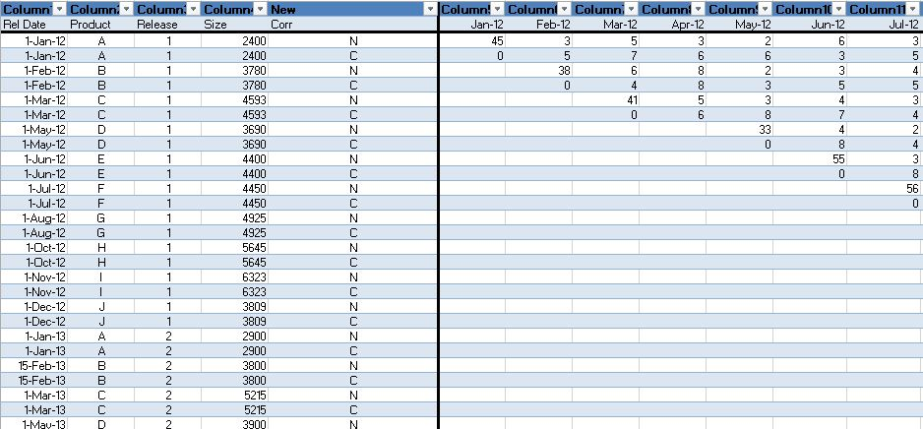

1. Current quality by number: This sheet contains data of all the products for 3 years. Total uncorrected defects are detected and then these are normalized by the number of active products. The sheet looks like this :

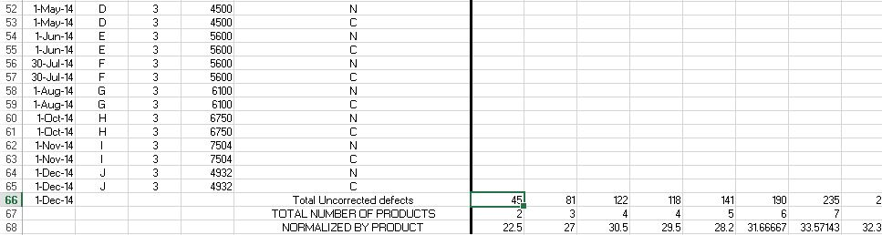

1. Current Quality by size: The sheet contains data for all the products for 3 years. Total uncorrected defects are calculated and these defects are normalized by size of current active products. The worksheet looks like this:

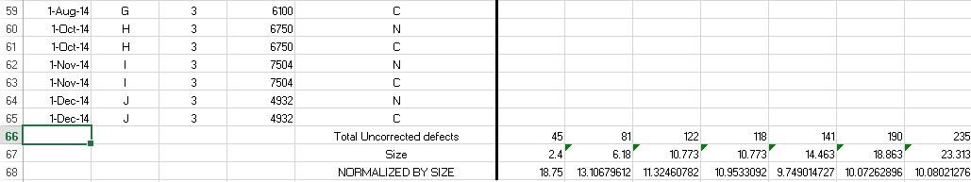

1. Standard deviation: The sheet contains data for all 3 years. Only the new defects of all the releases is analyzed. The mean and standard deviation of products is calculated. The worksheet looks like this:

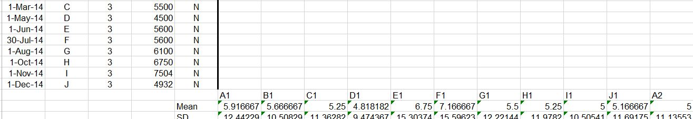

1. **Measures, Graphs and Analysis**
   1. **Post Release Quality**

Post release quality analyses the number of defects recorded after the product is released. It answers the question how many defects are in this product and how does total grow after release. Post release quality is measured for single product.

* + 1. **Overview**

Detected Defects are defined as the cumulative sum of all the defects both reported by the customer (post-release defects) and known to be in the product at release time (pre-release defects):

Equation 1 - Total Defects

Uncorrected Defects are defined as Total Defects minus the cumulative sum of all defects corrected:

Equation 2 - Uncorrected Defects

The data required for this measure are:

* DPRE – The number of known defects at release time.
* DRPT, i – The number of defects reported in the *ith* customer report.
* N – The total number of customer reports.
* DC – The number of defects corrected, reported monthly by engineering staff

Both DT and DUNC are plotted monthly on a line chart.

* + 1. **Sample Graph**

The figure below shows a Post Release Quality Chart for the first year of Project A’s Release 1.

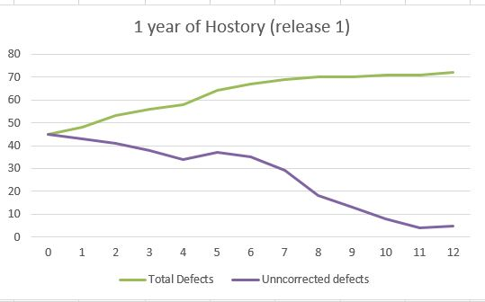

The next figure shows a three Post Release Quality Charts, one for each release of Project A.

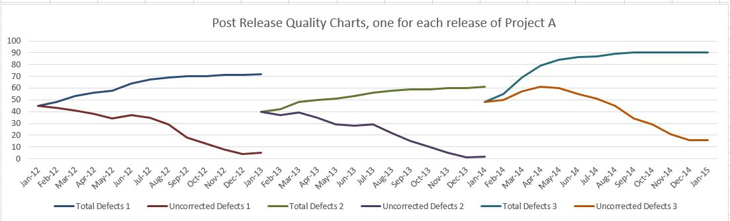

The next figure shows the Post Release Quality Charts for each of the three releases superimposed so their defect trends can be more closely compared.

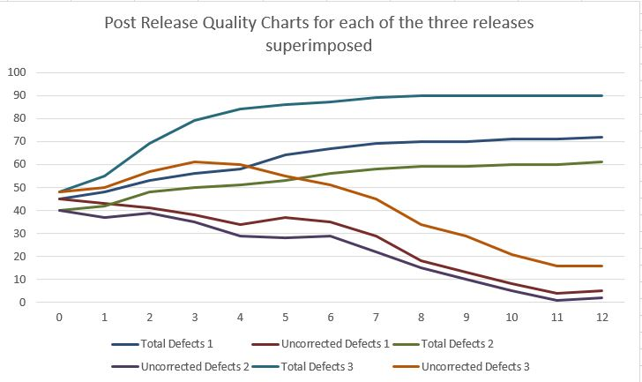

* + 1. **General Discussion**

The graph tells us about how many defects were known at the time of release and with time how many were detected. Two factors are calculated Total defects and uncorrected defects. It shows the total defects versus uncorrected defects.

The graph only considers the defects and no other factors such as size of the product.

* + 1. **Analysis of Graph**

We have plotted 3 graphs for post analysis

First graph is for 1 year release history for product A. The graph shows the though the line for total defects increase with time, the line for uncorrected defects is decreasing.

Second graph compares the 3 releases of product A over time. This graph shows the total number of defects and uncorrected defects for all the three releases and can be used to check for three releases individually.

Third graph superimposes all the three releases so that we compare the patterns of the three releases. We can see that release three has greatest number of total defects and uncorrected defects.

We can see that defects for release 2 were less than releases 1 and 3. This can be due to the defect reduction program.

* + 1. **Procedure Used to Produce Graph**

To plot the graph for post quality analysis we copies the new defects and corrected defects line for one year for product A release 1 for one year. Using equation 1 we calculated total defects and using 2 we calculates total uncorrected defects.

For graph 2 and 3 we used data of new defects and corrected defects for all releases of product A for 1 year.

We used lines total defects and uncorrected defects to produce line chart.

* 1. **Post Release Quality History**

Post Release Quality History is analyzed for several products released during a particular time period. It is a lagging indicator which is computed only after product has been out for 12 months. It answers the question “How good were the products we shipped in terms of defect rates?” Best case, average case and worst case are calculated for products release during a given time period.

* + 1. **Overview**

Total defects for a product is the cumulative sum of new defects detected over a period of 12 months

Equation 3:

The data required for this measure are:

DT = Total number of defects for single product

DPRE = Defects known at release time

DRPT= Defects reported per month for single product

For monthly analysis since only one product is released each moth best case, average case and worst case are all the same.

DT is used to graph the best case, average case and worst case for monthly release.

For quarterly we take 3 months for analysis:

Equation 4:

Where DT1 = Total Defects for Product 1 released in 3 months

DT2 = Total Defects for Product 2 released in 3 months

DT3 = Total Defects for Product 3 released in 3 months

Lines for best case, average case and worst case are plotted.

For Yearly Analyses:

Equation 5 :

Lines for Best case, Average case and worst case are plotted.

* + 1. **Sample Graph**

Graph for post release quality history monthly: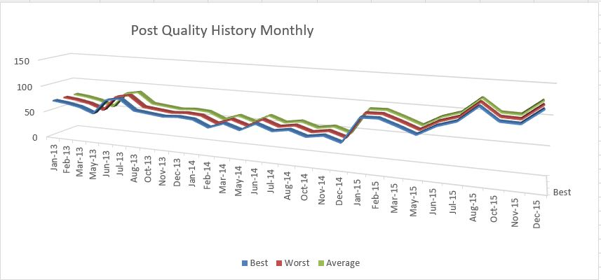

Graph for post release quality history quarterly

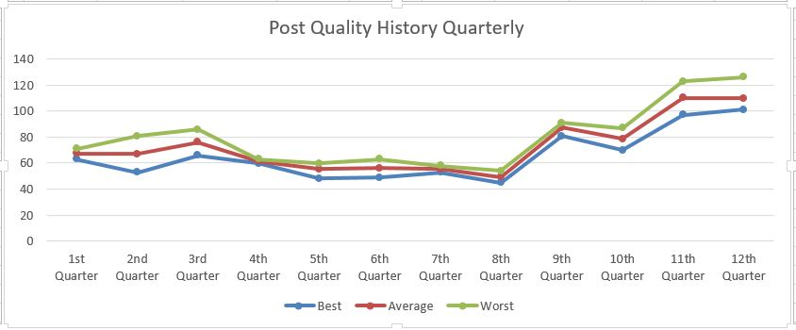

Graph for post release quality history yearly: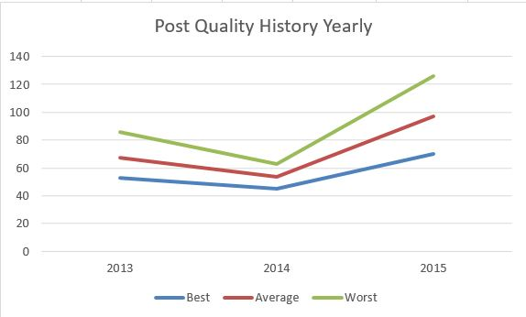

* + 1. **General Discussion**

This graph tells us about only the total defects recorded and not the corrected or uncorrected defects. This technique helps us analyze the data monthly, quarterly and yearly. Monitoring the data in 3 ways tells us how frequently we should monitor the data. Monitoring too often may cost a lot and would benefit a little. Monitoring too little may not give us correct insight of what is happening. This kind of analysis is useful when we have a lot of data to analyze.

The previous graph .i.e. Post quality analysis does not tell us defect rates.

* + 1. **Analysis of Graph**

First graph analysis the monthly data where there is just one or 0 release each month. Hence this graph would not be that useful in analysis and best case, worst case and average case all are the same.

In second graph we analyze data quarterly where we take the total releases in 3 months. In our case there are 2 or 3 releases in a month for 1 year. We see that best case, average case and worst case are very close to each other. The graph shows that there are less number of defects from 4th quarter to 8th quarter and then gradually starts increasing. There are large number of defects from 10th quarter to 12th quarter.

In third graph we plot the graph yearly for 3 years. We take all the releases in a year. From these releases we find out best case, worst case and average case to plot the three cases. For 3 years we see that best case, worst case and average case shows similar lines, also we have more number of defects in last year than in last year. There are less number of defects in 2014 and then defects starts increasing in 2015. This is due to cost reduction program in 2015 that led to degradation in quality and increase in defects.

* + 1. **Procedure Used to Produce Graph**

For Post Quality History Analysis data with only new defects rows in used for 3 full years. Corrected defects, size and other data is not used.

For first graph Total number of defects for 1 year are calculated for a product using equation 3. Since there is 0 or 1 release per month best case, average case and worst case are all the same.

For second graph Total defects of a product for 1 year are calculated for a product using equation 3. In 3 months we have 0 or 3 releases for a month. From these releases in 3 months worst case, best case and average cases are calculated using equation 4. Then Best case, worst case and average calculated for 3 months are calculated and plotted on graph.

For third graph total defects for all the products are calculated using equation 3. Best case, worst case and average cases are calculated for 1 year using equation 5 and plotted on the graph

* 1. **Current Quality Total**

Current Quality total calculates the total uncorrected defects for all active products. It answers the question “How many defects are out this month in all currently supported products?” It helps us analyze whether we need more resources for defect correction.

* + 1. **Overview**

Data for 3 years is used for all products using both new defects and corrected defects.

Detected Defects are defined as the cumulative sum of all the defects both reported by the customer (post-release defects) and known to be in the product at release time (pre-release defects):

Equation 6

Uncorrected Defects are defined as Total Defects minus the cumulative sum of all defects corrected:

Equation 7

The data required for this measure are:

* DPRE – The number of known defects at release time.
* DRPT, i – The number of defects reported in the *ith* customer report.
* N – The total number of customer reports.
* DC – The number of defects corrected, reported monthly by engineering staff
* DUNC – Uncorrected defects

DUNC is used to plot current quality.

* + 1. **Sample Graph**

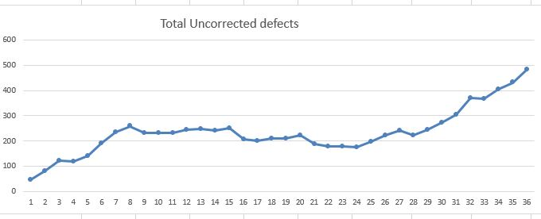

* + 1. **General Discussion**

The graph tells us about the uncorrected defects in currently active products. It helps us analyze the health of the current active releases.

The previous graphs does not tells us about the current condition of the active products.

* + 1. **Analysis**

According to our graph plotted the number of uncorrected defects are increasing with time for currently active products. The data for 3 years is used to analyze. This shows that quality of product is decreasing.

* + 1. **Procedure Used to Produce Graph**

Data for 3 years is used with both new defects and corrected defects.

Equation 6 and equation 7 are used to calculate total uncorrected defects out for currently active products.

Uncorrected defects are used to plot the graph

* 1. **Current Quality Total Normalized by Active Product Size**

Current Quality total Normalized by size analyses the uncorrected defects with respect to size of currently active products. Defects are normalized by size to determine raw level of defect production as programmer sees it.

* + 1. **Overview**

Equation 6 and Equation 7 are used to calculate uncorrected defects.

To normalize by size we use following equation

S= (Size)/1000.

Equation 8 :

CQNBS = DUNC / S

Where CQNBS = Current quality normalized by size

DUNC = Uncorrected defects

S = Size of active products in KLOC

* + 1. **Sample Graph**

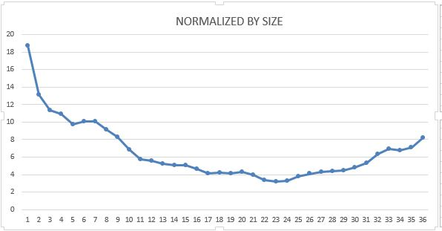

* + 1. **General Discussion**

For this technique we normalize the current quality by the size of currently active products. This technique helps the programmer to estimate the level of defect production.

* + 1. **Analysis**

As we see when we normalize the current quality by size the graph gradually decreases. But now the defects are calculated depending on the size of active products.

* + 1. **Procedure Used to Produce Graph**

Data for 3 years is analyzed. Size of product, new defects and corrected defects lines are considered. Uncorrected defects is calculated for the current active products. The defects are normalized by the size of currently active products divided by 1000 for KLOC. The uncorrected defects of a particular month are divided by the total size of products active in that month.

* 1. **Current Quality Total Normalized by Number of Active Products**

This technique is used to analyze the uncorrected defects with respect to the number of products active in that time interval. Defects are normalized by number of products to determine how the customer sees it.

* + 1. **Overview**

Equation 6 and 7 are used to calculate the total uncorrected defects.

Equation 9:

CQNBS = Uncorrected defects / N

Where N = Total number of active products

* + 1. **Sample Graph**

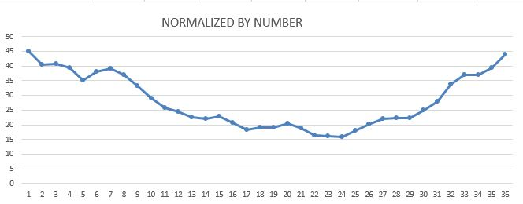

* + 1. **General Discussion**

The graph used to determine the customer’s view. The techniques helps us to analyze defects with respect to currently active products.

This graphs tells us current uncorrected defects out and number of products active. The graph is plotted using these two factors.

* + 1. **Analysis**

The graph is plotted for 3 years. As we can see in firs year and second year the defect level is decreasing but in third year the defect level starts increasing. But in this graph defects are calculated depending on number of active products.

* + 1. **Procedure Used to Produce Graph**

The data for 3 years is analyzed for products. The new defects and corrected defects both are analyzed for this technique.

Equation 6 and 7 are used to calculate uncorrected defects. The uncorrected defects are then divided by the total number of active products.

* 1. **Standard deviation of defects**

The quality of product is determined using the standard deviation of defects of each product. It answers the question “How good are the products released so far?” Standard variation gives the amount of variation i.e. how tightly are data points clustered around mean. It tells us how much variation exists.

* + 1. **Overview**

Formula used for standard deviation is:

Equation 10:

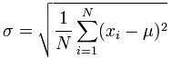

Where N= Number of defects

Xi = current defects

µ = mean of all values

Equation 11:

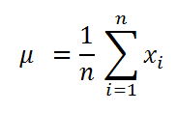

Graph for mean is plotted and standard deviation is shown on the graph

* + 1. **Sample Graph**

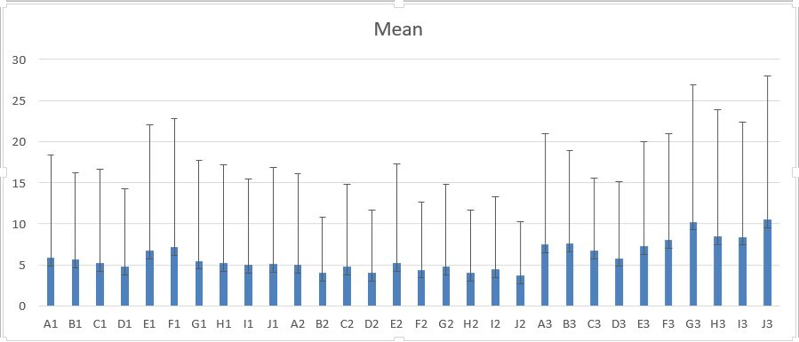

* + 1. **General Discussion**

This graph helps us analyze the variance. Using this technique we can focus on minimizing the variance which would improve the quality and customer satisfaction. Using the standard deviation we can also predict the future defects.

* + 1. **Analysis**

As we can see from the graph, we can analyze the deviation of defects for each release. The graph shows that for products A,B,C,D,G,H,I,J deviation of defects is the most in 3rd release, for product E,F the deviation is the most in release 1. Hence we can conclude that cost reduction program led to degradation in our quality of products. Due to defect reduction program in 2012 and 2013, the number of defects reduced but in 2014 due to cost reduction program the quality of products reduces leading to increase in number of defects.

* + 1. **Procedure Used to Produce Graph**

The data for all 3 years is analyzed for new defects of each product.

For plotting the graph we first find the mean of defects for all the product releases using equation 11.

For finding the standard deviation of the defects of all product releases we use equation 10.